SCRIPT TRIỂN KHAI KỊCH BẢN RABBITMQ

1) Chuẩn bị hạ tầng

VM (Azure)
- Ubuntu 24.04 LTS
- Public IP (tĩnh hoặc dynamic đều được)
- Mở inbound (NSG):
  - 22/tcp (SSH)
  - 5672/tcp (RabbitMQ AMQP) Source = My IP
  - 15672/tcp (RabbitMQ Management UI) Source = My IP
  - 9090/tcp (Prometheus UI/API)
  - 3000/tcp (Grafana Web UI)

PC (Macbook)
- Python 3
- pip / venv hoạt động

2) VM: Cài Docker + Docker Compose
SSH vào VM:
ssh -i ~/<DUONG_DAN_KEY>.pem <user>@<VM_PUBLIC_IP>
ssh -i ~/Downloads/NT531-vm_key.pem azureuser@20.189.74.208
Cài Docker:
sudo apt-get update
sudo apt-get install -y ca-certificates curl gnupg
sudo install -m 0755 -d /etc/apt/keyrings
curl -fsSL https://download.docker.com/linux/ubuntu/gpg | sudo gpg --dearmor -o /etc/apt/keyrings/docker.gpg
sudo chmod a+r /etc/apt/keyrings/docker.gpg
echo \
"deb [arch=$(dpkg --print-architecture) signed-by=/etc/apt/keyrings/docker.gpg] https://download.docker.com/linux/ubuntu \
$(. /etc/os-release && echo "$VERSION_CODENAME") stable" | \
sudo tee /etc/apt/sources.list.d/docker.list > /dev/null
sudo apt-get update
sudo apt-get install -y docker-ce docker-ce-cli containerd.io docker-buildx-plugin docker-compose-plugin
sudo usermod -aG docker $USER
newgrp docker
docker --version
docker compose version

3) VM: Chạy RabbitMQ bằng Docker Compose (KHÔNG POSTGRES)
mkdir -p ~/mq-lab && cd ~/mq-lab
cat > docker-compose.yml <<'YAML'
services:
rabbitmq:
image: rabbitmq:3-management
restart: unless-stopped
ports:
- "5672:5672"
- "15672:15672"
environment:
RABBITMQ_DEFAULT_USER: admin
RABBITMQ_DEFAULT_PASS: admin123
YAML
docker compose up -d
docker ps
Kiểm tra UI:
- Mở: http://<VM_PUBLIC_IP>:15672
- Mở: http://20.189.74.208:15672
- Login: admin / admin123
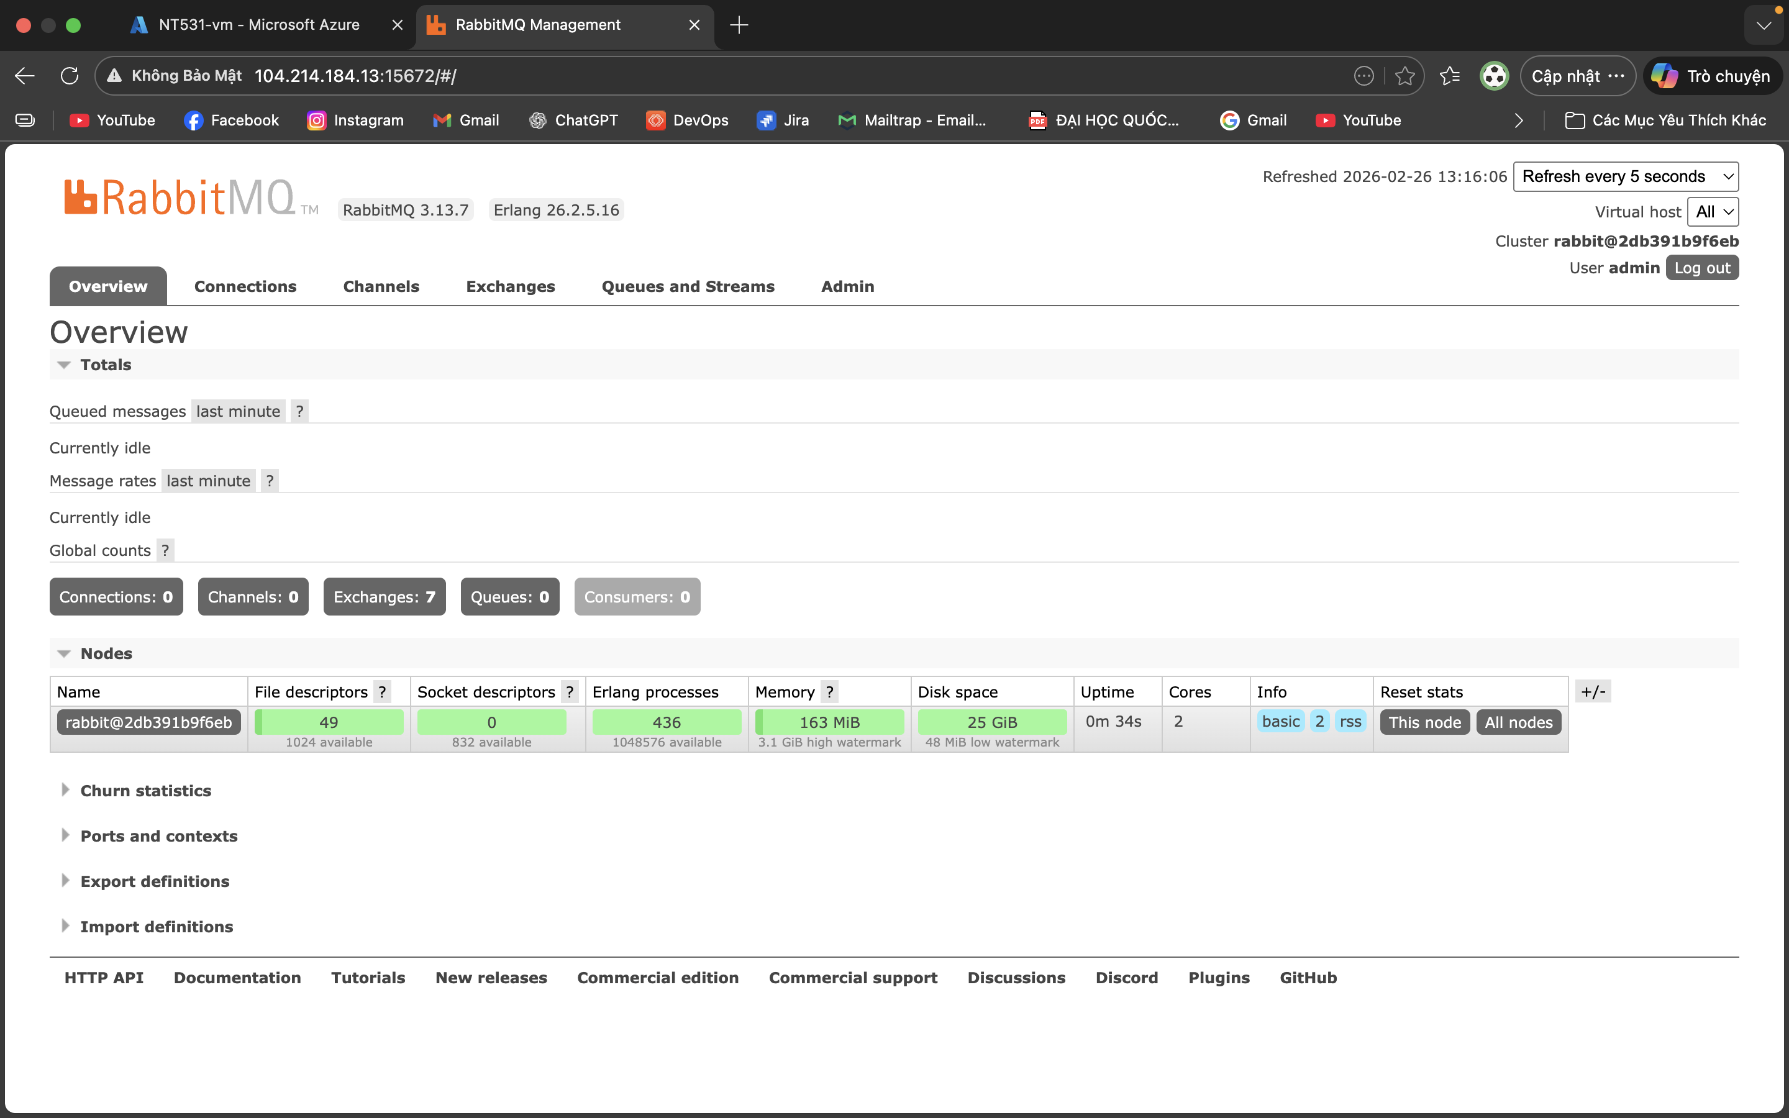

4) VM: Setup Python Worker benchmark (Consumer/Worker)
Cài python + venv + pika:
sudo apt-get update
sudo apt-get install -y python3 python3-venv python3-pip
mkdir -p ~/work-queue && cd ~/work-queue
python3 -m venv .venv
source .venv/bin/activate
pip install pika

4.1 Tạo file worker.py (Đã có trên cloud chỉ cần download về)

4.2 Tạo các file bash để automation gồm run_one.sh, run_workers_until_drained.sh, run_workqueue_matrix(Đã có trên cloud chỉ cần download về)

5) Setup Producer benchmark
cd ~/work-queue
python3 -m venv .venv
source .venv/bin/activate

5.1 Tạo file producer.py (Đã có trên GIT chỉ cần download về)

6) VM: SETUP PROMETHEUS + GRAFANA + EXPORTERS

1) Bật Prometheus metrics cho RabbitMQ
RabbitMQ có plugin Prometheus sẵn. Với image rabbitmq:3-management, bạn bật bằng env hoặc lệnh.

Cách chắc chắn: bật plugin bằng docker exec
Trên VM:
docker exec -it mq-lab-rabbitmq-1 rabbitmq-plugins enable rabbitmq_prometheus
Plugin này expose metrics ở:
- http://<VM_IP>:15692/metrics
Port 15692 là metrics endpoint. Bạn không cần mở ra Internet nếu Prometheus chạy cùng VM.

2) Docker Compose thêm Prometheus + Grafana
Trong ~/mq-lab/docker-compose.yml, bạn có thể đổi sang bản có đủ 3 service:
cd ~/mq-lab
cat > docker-compose.yml <<'YAML'
services:
rabbitmq:
image: rabbitmq:3-management
restart: unless-stopped
ports:
- "5672:5672"
- "15672:15672"
# 15692 không cần public nếu prometheus chạy cùng network, nhưng mở ra localhost cũng được
- "15692:15692"
environment:
RABBITMQ_DEFAULT_USER: admin
RABBITMQ_DEFAULT_PASS: admin123
prometheus:
image: prom/prometheus:latest
restart: unless-stopped
ports:
- "9090:9090"
volumes:
- ./prometheus.yml:/etc/prometheus/prometheus.yml:ro
depends_on:
- rabbitmq
grafana:
image: grafana/grafana:latest
restart: unless-stopped
ports:
- "3000:3000"
depends_on:
- prometheus
YAML
Tạo prometheus.yml:
cat > ~/mq-lab/prometheus.yml <<'YAML'
global:
scrape_interval: 5s
scrape_configs:
- job_name: "rabbitmq"
static_configs:
- targets: ["rabbitmq:15692"]
YAML
Restart:
docker compose up -d
docker ps
Bật plugin prometheus (nếu chưa):
docker exec -it mq-lab-rabbitmq-1 rabbitmq-plugins enable rabbitmq_prometheus

3) Vào Grafana và add Prometheus datasource
- Mở: http://<VM_PUBLIC_IP>:3000
- Login mặc định: admin / admin (Grafana sẽ bắt đổi password)
- Add data source → Prometheus
  - URL: http://prometheus:9090
  - Save & test

4) Tạo dashboard nhanh (panel gợi ý)

1 — Kich Ban 1

Panel A — Queue Ready (độ sâu hàng đợi)
Query (thường gặp):
- rabbitmq_queue_messages_ready

Panel B — Unacked
- rabbitmq_queue_messages_unacked

Panel C — Total
- rabbitmq_queue_messages

Panel D — Consumers
- rabbitmq_queue_consumers

Panel E — Publish rate
Thường dùng counter → lấy rate:
- rate(rabbitmq_channel_messages_published_total[1m])

Panel F — Ack rate
- rate(rabbitmq_channel_messages_acked_total[1m])

2 — Kich Ban 2
Panel 1 - rabbitmq_queue_messages_ready{queue=~"subq_.*"}
Panel 2 - rabbitmq_queue_messages_unacked{queue=~"subq_.*"}
Panel 3 - rabbitmq_queue_messages_unacked{queue=~"subq_.*"}
Panel 4 - rabbitmq_consumers
Panel 5 - sum(rate(rabbitmq_channel_messages_published_total{exchange="broadcast_x"}[1m]))
Panel 6 - rate(rabbitmq_channel_messages_acked_total[1m])

Tính avg_ms và p95_ms
python3 - <<'PY'
import glob, json, math, statistics as st
vals=[]
for fn in glob.glob("/home/azureuser/work-queue/w*.jsonl"):
with open(fn) as f:
for line in f:
if '"net_latency_ms"' not in line:
continue
d=json.loads(line)
v=d.get("net_latency_ms")
if isinstance(v,(int,float)) and v>=0:
vals.append(v)
vals.sort()
avg=st.mean(vals) if vals else 0
def pct(p):
k=(len(vals)-1)*p
f=math.floor(k); c=math.ceil(k)
if f==c: return vals[int(k)]
return vals[f] + (vals[c]-vals[f])*(k-f)
p95=pct(0.95) if vals else 0
print(f"count={len(vals)} avg_ms={avg:.2f} p95_ms={p95:.2f}")
PY
Đếm messages của workers: wc -l ~/work-queue/w*.jsonl
Xoá số messages của workers: rm -f ~/work-queue/w*.jsonl
Xoá log cpu: rm -f cpu_rabbit.log
Log CPU:
for i in {1..60}; do docker stats --no-stream --format "{{.Name}} {{.CPUPerc}}" mq-lab-rabbitmq-1 >> cpu_rabbit.log; sleep 1; done

python3 - <<'PY'
import re, statistics as st
vals=[]
for line in open("cpu_rabbit.log"):
m=re.search(r"([\d.]+)%", line)
if m: vals.append(float(m.group(1)))
print("samples",len(vals),
"avg_cpu%", round(st.mean(vals),2),
"max_cpu%", round(max(vals),2))
PY

